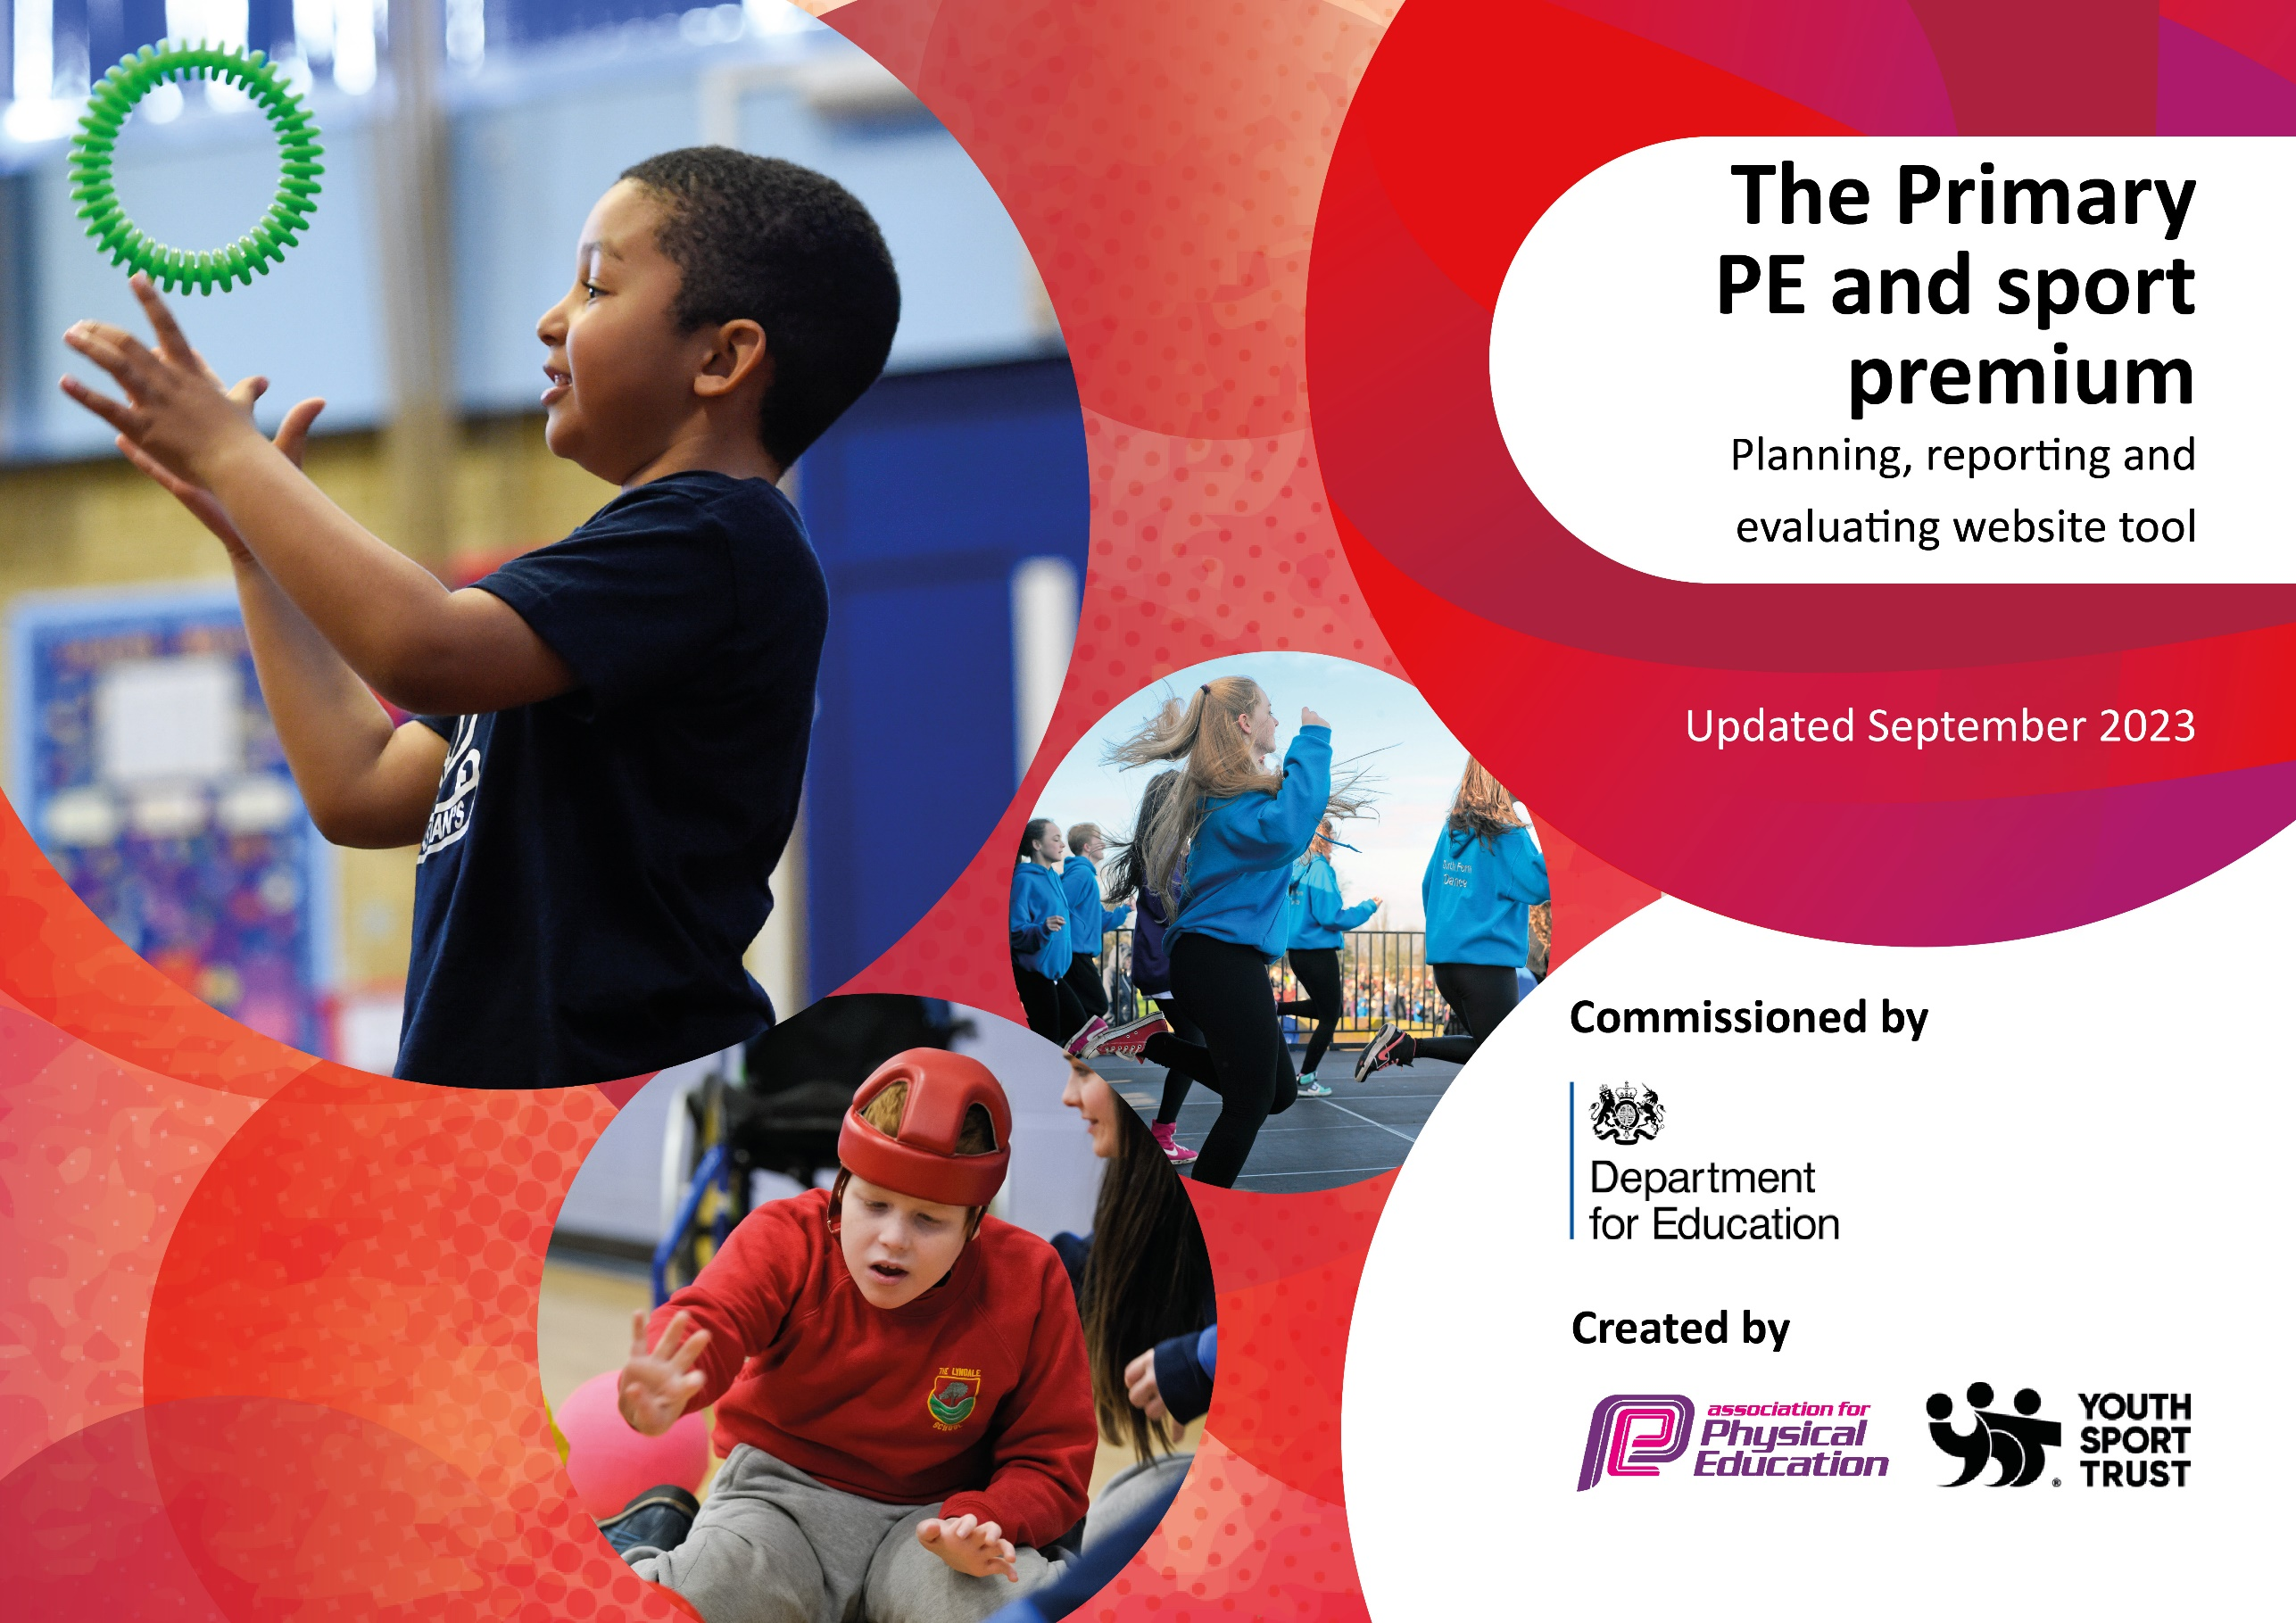

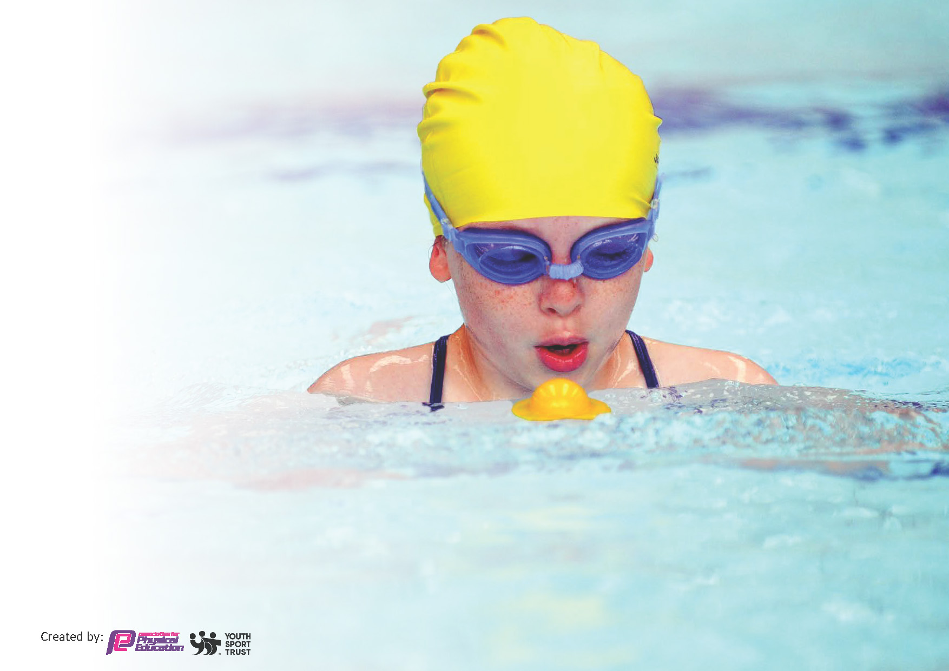
This template can be used for multiple purposes:
by:
- It enables schools to effectively plan their use of the Primary PE and sport premium
- It helps schools to meet the requirements (as set out in guidance) to publish information on their Primary PE and sport premium
- It will be an effective document to support Ofsted inspections enabling schools to evidence progress in Physical Education (PE) and evidence swimming attainment, which forms part of the PE National Curriculum. We would recommend schools consider
the Intent, Implementation and Impact of any spend, as examined within the Education Inspection Framework.

It is important that your grant is used effectively and based on school need.

Schools must use the funding to make additional and sustainable
improvements to the quality of the PE, School Sport and Physical Activity (PESSPA)
they offer. This means that you should use the Primary PE and sport premium to:

- Build capacity and capability within the school to ensure that improvements made now will benefit pupils joining the school in future years
- Develop or add to the PESSPA activities that your school already offers.

The Primary PE and sport premium should not be used to fund capital spend projects; the school’s core budget should fund these. Further detail on capital expenditure can be found in the updated Primary PE and sport premium guidance.

The Primary PE and sport premium guidance, outlines 5 key priorities that funding should be used towards. It is not

necessary that spending has to meet all the key priorities, you should select the priorities that you aim to use any funding towards.

Although completing this template is not a requirement for schools, schools are required to publish details of how they spend this funding. Schools must also outline what the impact this funding has had on pupils’ PE and sport participation and attainment and how any spending will be sustainable in the future. All funding must be spent by 31st July 2024.

The Department for Education has worked closely with the Association for Physical Education (afPE) and the Youth Sport Trust (YST) to develop this template and encourages schools to use it. This template is an effective way of meeting the reporting requirements of the Primary PE and sport premium.
Review of last year’s spend and key achievements (2022/2023)

We recommend you start by reflecting on the impact of current provision and reviewing your previous spend.

Activity/Action | Impact | Comments

Key priorities and Planning
This planning template will allow schools to accurately plan their spending.

Action – what are you planning to do | Who does this action impact? | Key indicator to meet | Impacts and how sustainability will be achieved? | Cost linked to the action
Make lunchtimes more active | Lunchtime supervisors, teachers, coaches (lunchtime clubs)  Pupils – as they will take part. | Key indicator 2 -The engagement of all pupils in regular physical activity – the Chief Medical Officer guidelines recommend that all children and young people aged 5 to 18 engage in at least 60 minutes of physical activity per day, of which 30 minutes should be in school.  Key indicator 4: Broader experience of a range of sports and activities offered to all pupils. | More pupils meeting their daily physical activity goal, more pupils encouraged to take part in PE and Sport Activities. | £14,000 costs for climbing equipment, Opal Play, coach for lunchtime sports clubs

Coaching for teachers  Wide range of clubs and competitions | Specialist sports coach  Teachers  Pupils  Specialist sports coaches  Pupils | Key Indicator 1: Increased confidence, knowledge, and skills of all staff in teaching PE and sport.  Key indicator 3: raising the profile of PE and sport across the school, to support whole school improvement  Key indicator 5: Increased participation in competitive sport.  Key indicator 4: offer a broader and more equal experience of a range of sports and physical activities to all pupils  Key indicator 5: Increased participation in competitive sport. | Teachers are more confident to teach a range of sports  Teachers know the skills needed and the progression of these for the sports they are teaching  Children have a wide and varied range of sports clubs to choose from.  Children have the opportunity to take part in competitions. | £5,500 for sports coach (2x weekly) and PE SOW  £3,500 for specialist sports coaches to run after school clubs.  Membership of local Schools Sports Partnership  Transport to and from competitions

Key achievements 2023-2024
This template will be completed at the end of the academic year and will showcase the key achievements schools have made with their Primary PE and sport premium spending.

Activity/Action | Impact | Comments
Make lunchtimes more active  Coaching for teachers  Wide range of clubs and competitions | Lunchtime clubs have been well received and children have enjoyed being part of these.  Climbing equipment has been very popular and the children have been able to not only be more active but also build resilience and problem solving skills.  Teacher’s knowledge and confidence when teaching PE has grown as a result of having a sports coach in school twice a week and a clear SOW to follow.  Teachers have received a term of team teaching with the sports coach which has helped to develop their knowledge and skills of teaching sports where they felt less confident.  The PE SOW has given teachers clear guidance for the progression of skills needed for the different areas of PE that they have taught.  Children have enjoyed having a range of different sports clubs to attend and the uptake for these has been good. Many children have tried a new sport with some of them taking this up outside of school.  Some year groups have taken part in competitions against other schools and these have proved very popular with the children. They loved trying new activities and the competitive element as well, all were proud of how they had performed.  Other year groups have had specialist teachers in to teach the children, eg EYFS using balance bikes correctly. | We joined Opal Play in May and have begun the initial induction for this. This will be implemented from September when new members of staff join who will be overseeing and running this.  Lunchtime clubs to continue in the next academic year.  PE SOW and sports coach to continue next year due to moving to a two form entry across the school and therefore more new teachers.  Continue with a good range of after school clubs next academic year.  School to take part in more competitions against other schools, with as many year groups as possible going to inter-school events.

Swimming Data
Meeting National Curriculum requirements for swimming and water safety.
Priority should always be given to ensuring that pupils can perform safe self-rescue even if they do not fully meet the first two requirements of the National Curriculum programme of study

Question | Stats: | Further context  Relative to local challenges
What percentage of your current Year 6 cohort can swim competently, confidently and proficiently over a distance of at least 25 metres? | 44% | Children took part in swimming lessons during Year 4 but these were disrupted due to some restrictions still being in place due to COVID. Some of the children continued with lessons for a short time in Year 5 but this was limited due to availability at the local pool.
What percentage of your current Year 6 cohort can use a range of strokes effectively [for example, front crawl, backstroke, and breaststroke]? | 51% | As above

What percentage of your current Year 6 cohort are able to perform safe self-rescue in different water-based situations? | 24% | As above.
If your schools swimming data is below national expectation, you can choose to use the Primary PE and sport premium to provide additional top-up sessions for those pupils that did not meet National Curriculum  requirements after the completion of core lessons. Have you done this? | Yes/No | Limited availability at the local pool meant that extra top-up sessions could not take place.
Have you provided CPD to improve the knowledge and confidence of staff to be able to teach swimming and water safety? | Yes/No

Signed off by:

Head Teacher: | (Name)
Subject Leader or the individual responsible for the Primary PE and sport premium: | Kirstie Burrells – EYFS Lead & Sports Premium
Governor: | (Name and Role)
Date:

